Customer problem statement

Navigation software based on traffic monitoring has been widely used in people's large-scale life. In China, Gaode Navigation and Baidu Map are two major navigation software providers. They provide the best path navigation based on real-time traffic monitoring. These are the navigation software being used by users. They can provide users with the same time when the customer queries the road conditions and arranges the travel plan according to the database in the software system. The information is for the user to report the road condition and arrange the travel plan, but the user often does not start immediately after the inquiry. Therefore, since the road condition information at the time of the inquiry is inconsistent with the road condition information when the user travels, the user may be affected. Our project attempts to change the way the traditional navigation software is provided, and provides a prediction of the road conditions of the travel plan. If the user can set the travel time, then the information in the previous database can be used to arrange the travel of the customer. This method reduces the impact on the user's travel by conditions that can predict the impact of road conditions (such as weather causes, up and down peaks, holiday holidays...). According to the travel plan generated by the system and the reason that the system predicts that may affect the travel, the user has a general understanding of the entire trip, so as to select the favorite plan.

Our project is based on traffic monitoring technology to upgrade and upgrade existing navigation software. A Sias student plans to take the train home tomorrow. In order to improperly travel, he has to arrange his travel time reasonably. Since the school is some distance from Zhengzhou Railway Station, he plans to arrange his own time according to the navigation system. The navigation gave him the following plans 1: It takes about 1 hour to ride a car; 2: It takes about 10 hours to walk; 3: Take a bus, change it to 2 times in the middle, it takes 2 hours and 30 minutes. He chose to take the car from the school to the train station. In order to improperly miss the trip, he set off 2 hours and 30 minutes in advance the next day. The next day he took his luggage to the door of the European street, but because of the day there was a lot of The student had to go from school to Zhengzhou, causing the shortage of vehicles. After he had queued for 30 minutes, he got on the bus, but the vehicle just started to rain when the vehicle started to fly. The speed was reduced for the safety driver, but the speed of the vehicle was reduced. The vehicle was blocked on the highway, and the entire journey took 2 hours. When the students arrived at the train station, the train stopped checking and departed. Due to the weather, the road conditions changed. However, the classmate’s plan was based on yesterday’s road conditions, which led to a change in the class’s itinerary.

The navigation that appears in these markets, in order to make a plan, does not change the plan in time according to the weather conditions and road conditions, combined with the student's experience. We have improved the navigation on the market. We designed the system to collect all the information that can affect the road conditions. Then, according to the destination and time set by the customer, the plan will be revised according to the collected data. Until the customer starts to start the journey.

The plan that the user system can make for the household before departure

(1) The “Travel Plan” user has the following options:

A) Departure place: User enters the place of departure

B) Destination: User enters the arrival location

C) Time: User enters departure time

This plan is a plan that the system develops based on information collected that may have an impact on road conditions. This information includes weather, traffic at the same time in history, number of pedestrians on the road, etc... This plan is a plan that takes into account the information that can be predicted, but it does not only include these predictable changes in road conditions. 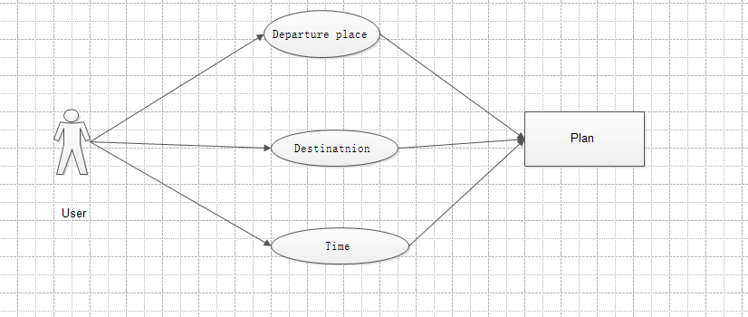In the case, there are still some unexpected situations that will change the road conditions, which will affect the user's travel and bring inconvenience to the users. In order to eliminate the unexpected situation, we have designed another method. The process is as follows:

(2) "Refresh plan" - adjust the plan according to the emergency situation

A) Interval: Set the time interval to collect information on the road conditions ahead.

B) Reset plan: According to the collected information, the system regenerates the plan and the user makes a new choice.

However, there are many uncertainties in these unexpected situations. Sometimes there are road jams in the car accidents on the expressway. Due to the traffic rules, we can only wait for the accident to be processed before we can start again.... We have no way to do this. Make changes, but in order to give the user a better experience, we set up a database information collection system.

(3) "Database"

A) "Reminder": User's radio button in the event of an emergency

B) “Problem feedback”: The multi-selection button and detailed problem description of the user's specific feedback on the problem encountered (in the case of security, or just button selection)

C): "Positioning Analysis": Analyze customer's problems with the user's location and the speed of the time traveled 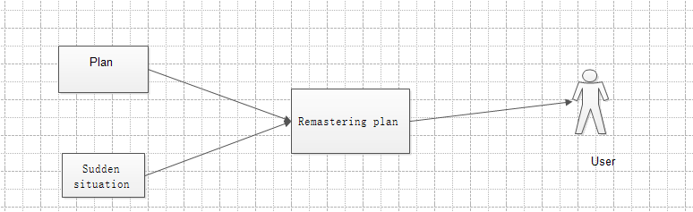

After the user makes a reminder, the system will send a message reminder to all users who have plans for the road here, and also generate a new travel plan for these users.